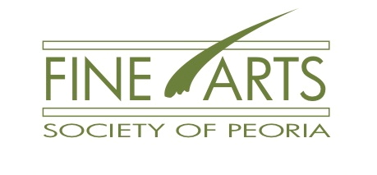
NOVEMBER 12, 2020 @ 10:00 AM * FREE via ZOOM
donations to Fine Arts Society of Peoria accepted at
PO Box 10002, Peoria, IL 61612

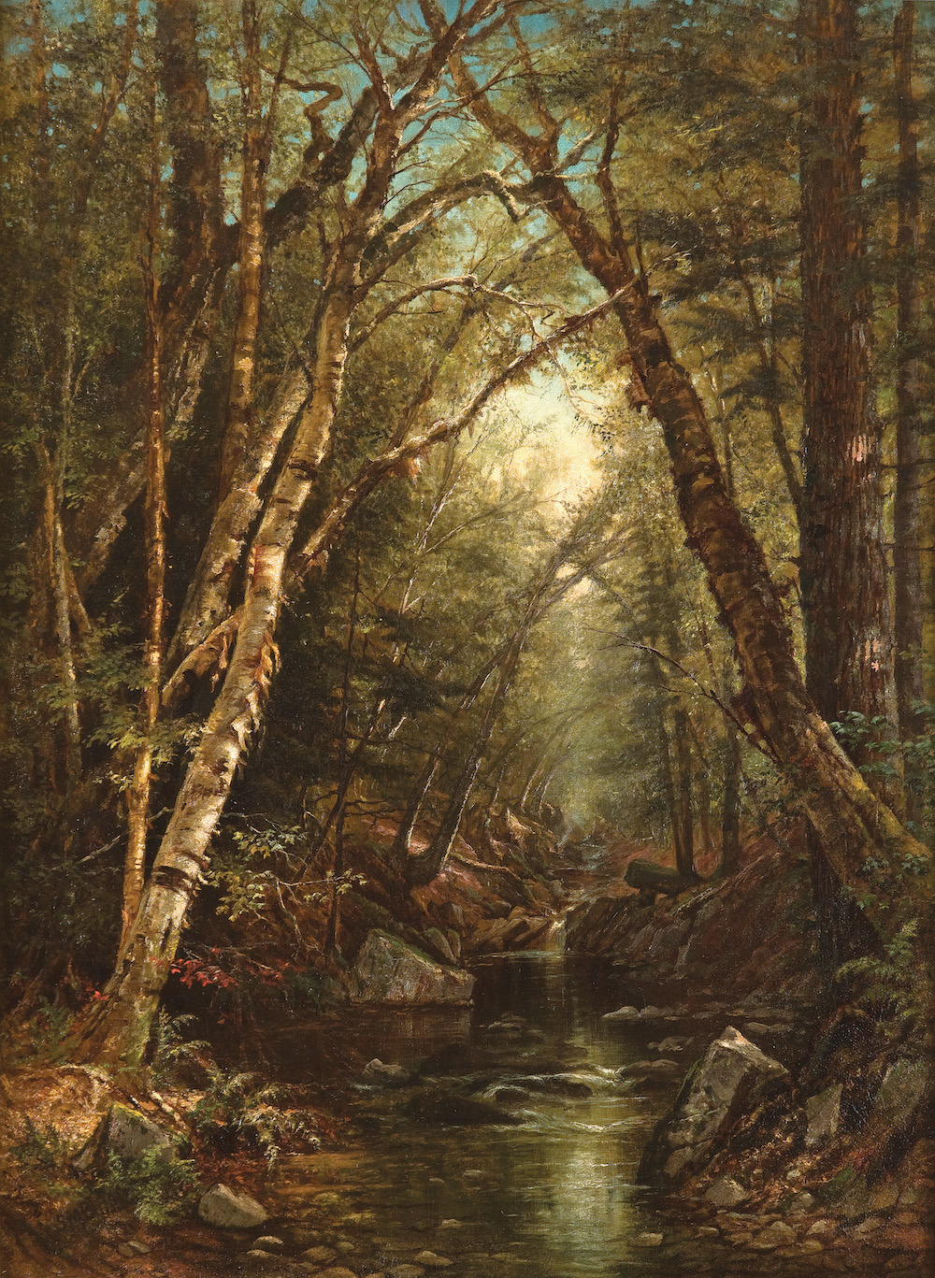
LECTURE by Dr. Nancy J. Siegel
'It Scarce Seems a Lady-Like Work':
Gender & Painting in the Hudson River School

European masters of landscape painting created works that displayed nature's beauty, power and awe, but their scenes, while based in nature, were mostly constructions of the mind. Artists of the Hudson River School, conversely, utilized the aesthetic theory of the academic past but looked to the actual mountains, rivers, and sky around them as their subject matter. The inclusion of the Hudson River in a
19th-century painting was often resonant with meaning.

The enormous success of these artists rested in part in their ability to produce scenes of wonder that resonated with the public. Most Americans interested in learning about or traveling to the Hudson Valley were part of an expanding middle class. Increasingly they purchased, if not original compositions on canvas, individual engravings, travel guides, books of poetry, and illustrated books dedicated to celebrating the picturesque and sublime qualities of the American landscape. American women became increasingly involved in the discovery and documentation of the vast and still largely unexplored lands of the United States. Some of these adventuresome women recorded their impressions of the awe-inspiring landscape in paintings, despite the many inequities they faced.

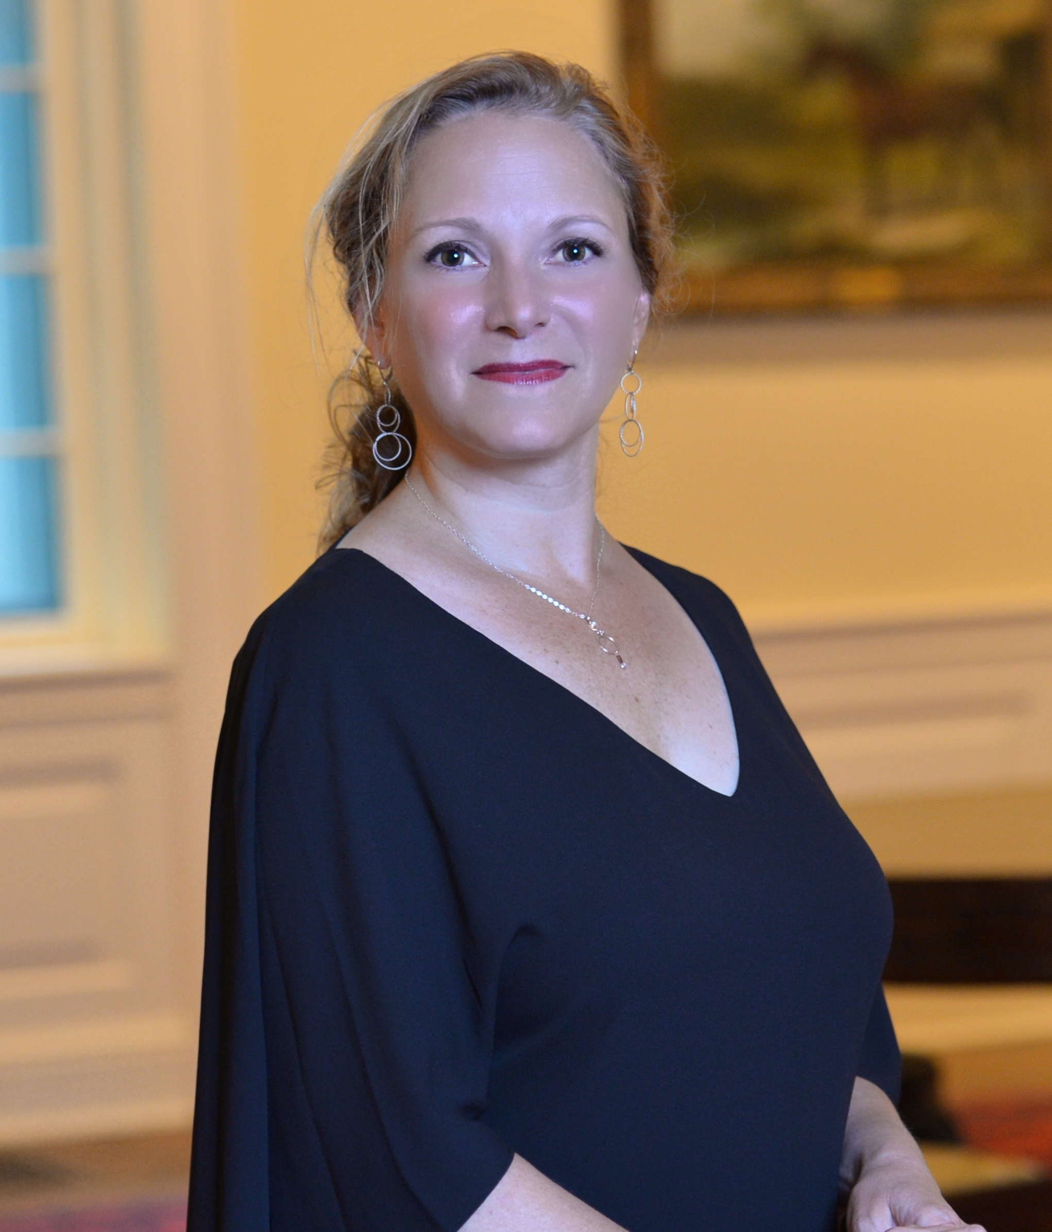
Dr. Siegel will discuss the Hudson River Valley School of painting in 19th century America, giving special attention to a group of women artists that have until recently been over-looked by scholars of this topic. Siegel is Professor of Art History at Towson University in Towson, MD. She specializes in American landscape studies, print culture, and culinary history of the 18th and 19th centuries. She has written and lectured extensively, on a number of 19th century topics. She holds an BA in Art History from Franklin and Marshall College, as well as an MA Art in History and Museum Studies Program Certificate and a PhD in Art History from Rutgers University.

Register in advance for this meeting:
https://us02web.zoom.us/meeting/register/tZUkc--oqzsvE90JxCy7V8gNp3c6VH7XSWie
After registering, you will receive a confirmation email containing information about joining the meeting.

For more information and the full 2020-2021 schedule plus a membership form,
please visit www.FineArtsSociety.net or contact FAS_President@comcast.net.

EXPLORING * EXPANDING * ENLIVENING the Fine Arts in Peoria

