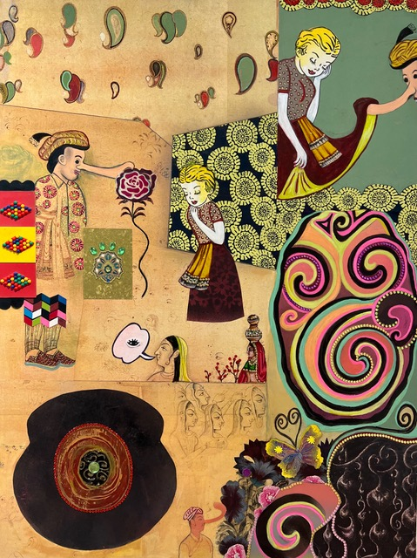

Pinocchio’s Folly, 2022
mixed media, collage, and paint on paper, mounted on panel
48 x 36”

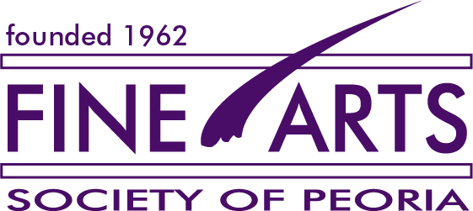
CHANNY LYONS MEMORIAL LECTURE FREE
by Chicago-based artist Phyllis Bramson
in conjunction with the exhibition
PHYLLIS BRAMSON
Mostly Folly (and a Few Kerfuffles)

Saturday, September 17, 2022 at 3:30 PM
Contemporary Art Center, 305 SW Water St., Peoria, Illinois
sponsored by Fine Arts Society of Peoria, Illinois Women Artists Project,
and Contemporary Art Center

exhibition: August 26 to October 15, 2022
reception: September 17, 2022 6:30 - 8:30 pm

Chicago-based Phyllis Bramson is known for her richly ornamental, excessive, and decadent paintings. She is greatly inspired by 18th century Rococo and chinoiserie designs, along with Chinese Pleasure Garden paintings and French painters Boucher and Fragonard. Her canvases are repositories for feelings, which often collide and intermingle between the personal and a grander narrative. Bramson is a key voice of her generation in Chicago. She was a long-time professor at the University of Illinois at Chicago, and now advises graduate students in drawing and painting at the School of the Art Institute of Chicago. Her work has been exhibited in key exhibitions and surveys at many institutions, had more than 40 solo shows, been widely recognized with numerous awards.

